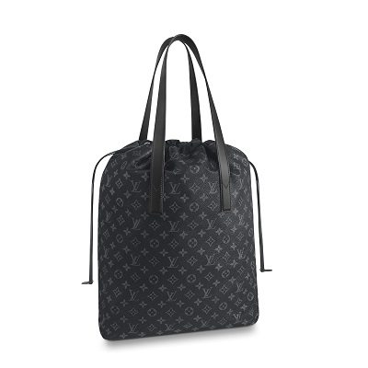

Cabas Light Monogram Eclipse Canvas

PRODUCT DETAILS

**- Monogram Eclipse coated canvas**

**- Textile lining**

**- Cowhide leather trim**

**- Silver colored metallic pieces**

**- 2 leather handles**

**- Drawstring opening**

**- 1 removable pouch**